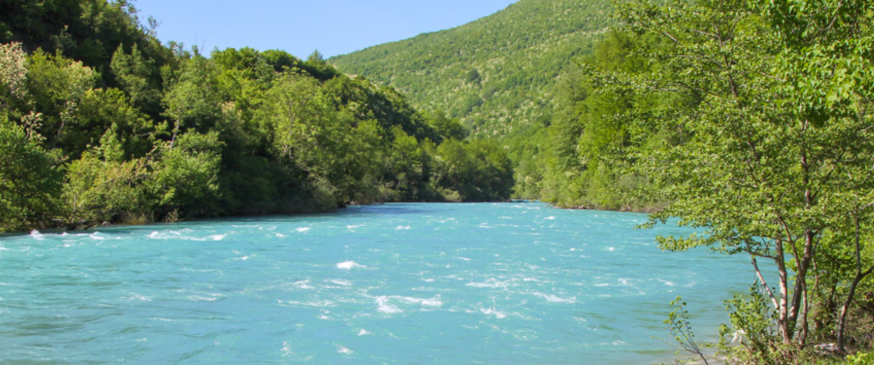
Preliminary Information Hydro Power Plant

Based on existing technical documentation.
- Installed capacity of 95 MW with possible expansion up to 125 mw,
- Annual production capacity of 330 Gwh, or with expansion up to 365 GWh,
- Water flow of min 350 up to 500 m3/second,
- Investment estimated at 185 million euro, with expansion around 225 million euro,
- Construction period is 2 + 3 years = total of 5 years,
- Current level of documentation, conceptual design is done, but should be adapted considering the expansion is feasible,
- Distance from the electricity grid is less than 20 km and there are several alternative directions,
- Participation as an investor - Concession,
- Model of implementation BOT,
- The law allows for a concession to last up to 50 years, this includes the construction period,
- The expropriation of the land has already been done on the location of the accumulation and a part of the access roads have already been build,
- Once we start our cooperation we will deliver the official documentation, which covers much more details,

The Concession holders expenses as defined by law:
- One time tax of 0,2% of the total investment value of the project, this is being paid upon receiving of the concession. The value is determined through the technical documentation based upon which the authorities grant the concession,
- An annual concession tax of 0,6% of the value of the sold energy, is being calculated on the generated and sold energy, during the concession duration,
- The compensation for water, land, ecology all together do not pass 4,5%. If we continue we will deliver all the legal documentation in which these elements are defined,
Additional preliminary information:
In order to be as transparent and clear the following information is important:
- The Investor at one time will need to:
- Provide/secure valid financial proof which can be presented to the authorities so they are certain that the investor can secure the financial means to implement the project (construct the power plant)
- Upon successful negotiations, rights are acquired from the relevant authorities in form of a Concession as also the exploitation rights, in accordance with the concession conditions. This will be achieved through a legal procedure which we will propose at the right time,
- The investor will receive the right to freely export and manage the generated electricity according to prices which he negotiates himself. During export no VAT is paid,
- The duration of the return of investment, depends on several factors, but one of the key is the price at which the generated energy will be sold. This power plant can increase its efficiency though increase of installed capacity MW, through increase of energy generation and with additional services, all of this can be achieved through careful planning of expenses and other elements which then again increase the efficiency of the power plant. The current estimation is that the power plant will pay itself of in 8 to 9 years,
- Keeping in mind that this is one of the most promising sectors specially because it is the purest form of renewable “ clean” energy, plus the big demand from the Italian market, plus the connection withe the underwater cable and the trans-balkan grid which connects Serbia, Montenegro, Italy (more precisely Obrenovac, Pljevlja, Tivat from there with the underwater cable to the South of Italy makes this project extra interesting,
- Besides this general information and suggestions about the project, we can provide all the additional information and suggestions required of how to implement this project successfully, this covers the entire process from legal information, the procedure of negotiation and acquiring of rights, organizing of all meetings with the relevant authorities and last but not least strong support and guidance so that all activities can be carried out successfully and efficiently,
- We are open to work with a serious investor who has the wish to build and operate power plants in this region and therefore have all the required information available for exchange, this includes a full strategy of the hydro power potential of this region and projects which can be connected,
- In short we deliver a service from A to Z guiding the investor towards efficient and successful realization.

